A

Report

On

Students’ Seminar
Session- 2022-23

Department of Philosophy
Rabindra Mahavidyalaya, Champadanga

Theme:
The concept of Pramana in Indian Philosophy
Venue: Department of Philosophy
Date: December 5, 2022
Organizer: Department of Philosophy
Paper Presenters: Students of Semester III & V (Hons.)
Audience: Students of Semester I, III and V (Hons.)
Objectives
- Learn a systematic study of ideas and issues;
- Pursuit of fundamental truths, a quest for a comprehensive understanding of the world, a study of principles of conduct and much more.
• Development of Discussion skills, exhibit independence and flexibility of thought, and time management;
- Stimulate listening skills, argumentative skills and critical thinking;

Proceedings
The seminar, hosted by Prof. Sukla Saha, began with the introductory speech given by Prof. Soumitra Das, Assistant Professor of Department of Philosophy of the institution. All three technical sessions were chaired by the departmental faculties. Prof. Hasina Sikdar and Prof. Sima Choudhury acted as judges. Prof. Sanchita Kheto monitored the whole session. There were three groups of paper presenters, each group containing not less than three students. All sessions were very interactive where pupils have been quite enthusiastic, and all of their questions have been satisfactorily answered. 51 students (Male: 10, Female: 41) participated in the seminar. The seminar ended with vote of thanks by Prof. Soumitra Das.
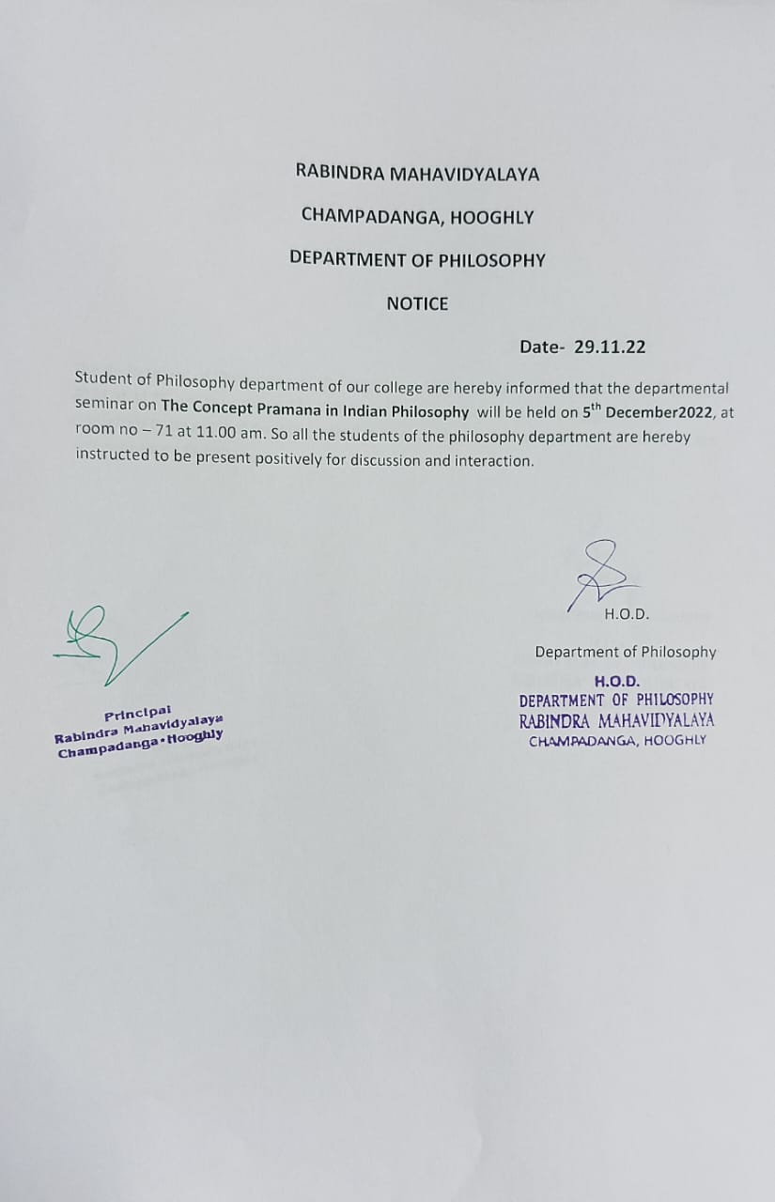

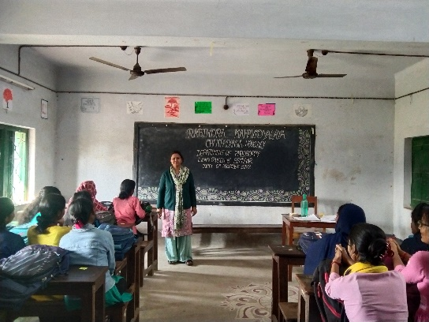
host
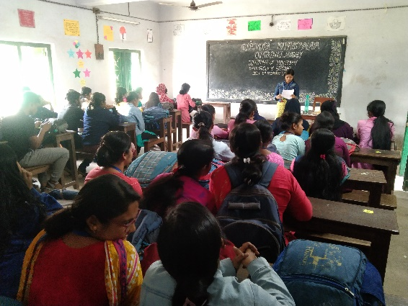
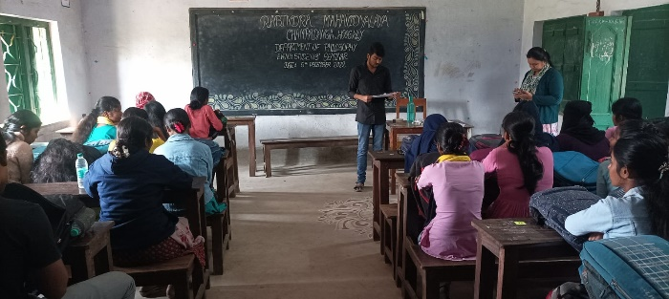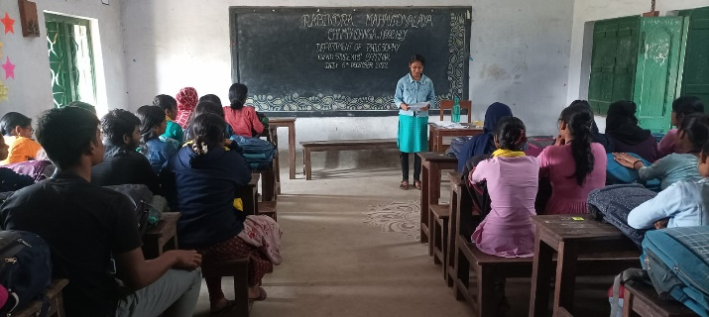
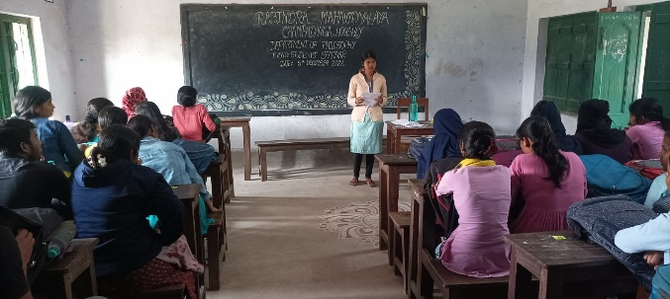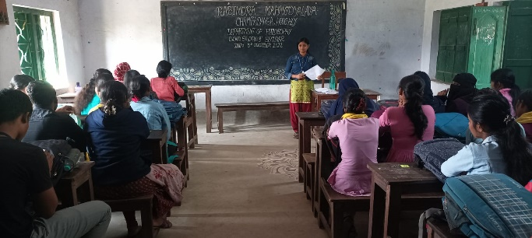
Paper present by students

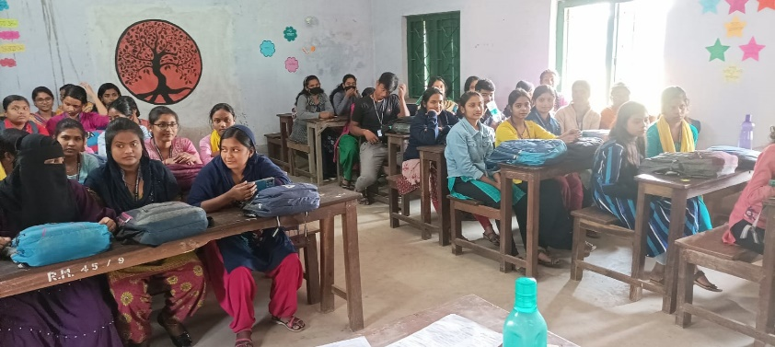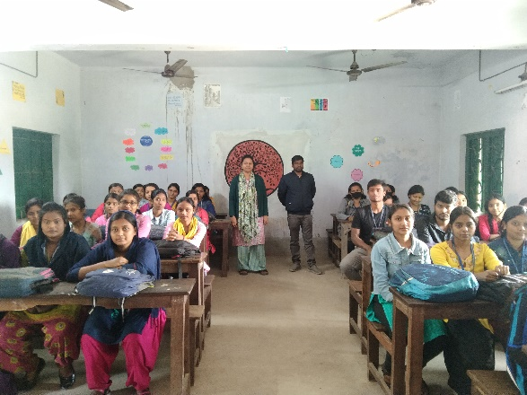
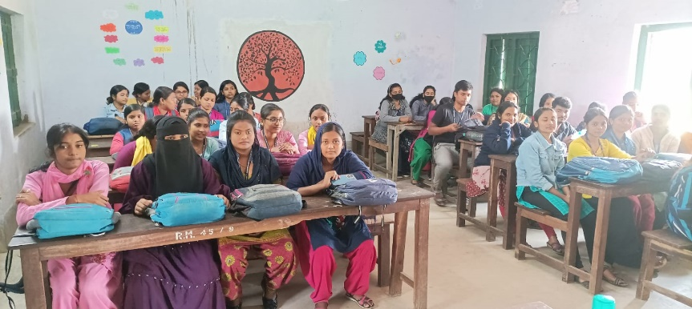
audience

Student’s Seminar
Theme: The concept of Pramana in Indian Philosophy
Date: 5.12.2022
Venue: Department of Philosophy, Rabindra Mahavidyalaya, Champadanga
Time: 12 noon to 3 p.m.

- Inauguration
- Principal’s Speech
- Technical Session 1: 12.30 p.m. to 1.15 p.m.

- Chairman: Soumitra Das
- Rapporteur: Sanchita Kheto
- Paper: Concept of Pramana according to Jaina Philosophy
- Lunch Break

- Technical Session 2: 1.30 p.m. to 2.15 p.m.

- Chairman: Hasina Sikdar
- Rapporteur: Sima Choudhury
- Paper: Nyaya Darshan-e Praman-er Dharona

- Technical Session 3: 2.20 p.m. to 3.05 p.m.

- Chairman: Sanchita Kheto
- Rapporteur: Soumitra Das
- Paper: Prama and Pramana: an analysis
- Prize Distribution
- Vote of Thanks: Prof. Soumitra Das

Student’s Seminar

List of Participants

Theme: The concept of Pramana in Indian Philosophy
Date: 5.12.2022
Venue: Department of Philosophy, Rabindra Mahavidyalaya, Champadanga
Time: 12 noon to 3 p.m.

- Paper: Concept of Pramana according to Jaina Philosophy

- Presenters: Sourav Jana, Tripti Adhikari, Rima Sasmal & Monisha Garai.

- Paper: Nyaya Darshan-e Praman-er Dharona

- Presenters: Soma Banerjee, Sarbojit Patra, Esa Manna & Radhasri Panja .

- Paper: Prama and Pramana: an analysis

- Presenters: Rikta Sasmal, Brishti Malik, Nisha Manna & Sayani Basu .

Feedback Summary
- 37 responses (73%) received.
- 82% felt satisfactory.
- 90% opined the event helped to improve their academic performance.
- 75% wished to occur the events more than once every year.

What have students learnt from the event?
- Presentation skills;
- Self-confidence;
- Critical thinking;

Suggestions
- More extra-curricular activities and healthy competition;
- Special class for grooming;

